Institution Details Table Creation
Project Development Phase | 3 of 7
Project | Script-Controlled ACL - Restrict Record Access Based on Field Value
Date / Team ID | 1 October 2026 | Team ID: [enter team ID]

Purpose
Create the custom Institution Details table used to hold student and faculty information. The Branch choice is the field checked by the ACL scripts.

Table definition
Setting | Value
Label | Institution Details
Suggested internal name | u_institution_details
Extends | Standalone custom table, unless your assignment specifies a parent table.
Access purpose | Store sample records by Branch for ACL testing.

Fields
Label | Type | Configuration
Student Roll Number | String | Example internal name: u_student_roll_number.
Student Name | Reference | Reference table: User [sys_user].
Faculty Name | Reference | Reference table: User [sys_user].
Branch | Choice | Add EEE, ECE, and CSE. Make required to avoid blank test records.
Email | String | Optional project contact field; use test data.
Phone Number | String | Optional project contact field; use test data.
Description | String | Short notes about the record.

Creation steps
- From the All navigator, open System Definition > Tables and select New. If your interface differs, search for Tables.
- Enter the Institution Details label and confirm the generated internal name. The video shows the table as u_institution_details.
- Add the seven fields in the table above. Set Student Name and Faculty Name to reference User [sys_user]. The screenshots show a sample record STU100 with student Abel Tuter, faculty Abraham Lincoln, and Branch ECE.
- Add Branch as a Choice field and confirm stored values, not only display labels. Screenshots show EEE, ECE, CSE, and a technical placeholder; remove the placeholder before the final demonstration.
- Save the table, then create one sample record for each Branch value.
- Verify the table and dictionary list show all seven project fields before adding ACLs.
Field name check ServiceNow may generate internal names from labels. Confirm the Branch field is actually u_branch before copying any ACL script.

Sample records for testing
Branch | Roll number example | Test purpose
EEE | STU-EEE-001 | Positive access case.
ECE | STU100 | Captured record: student Abel Tuter; faculty Abraham Lincoln.
CSE | STU-CSE-001 | Restricted branch case.

References
Project walkthrough: YouTube demonstration

Screenshot evidence and implementation alignment
Evidence summary: The table is u_institution_details (label Institution Details), with fields Student Roll Number, Student Name, Faculty Name, Branch, Email, Phone Number, and Description. Branch is a choice field; screenshots show EEE, ECE, CSE and a technical placeholder option. Remove that placeholder before final validation.
Institution Details table setup screenshot.
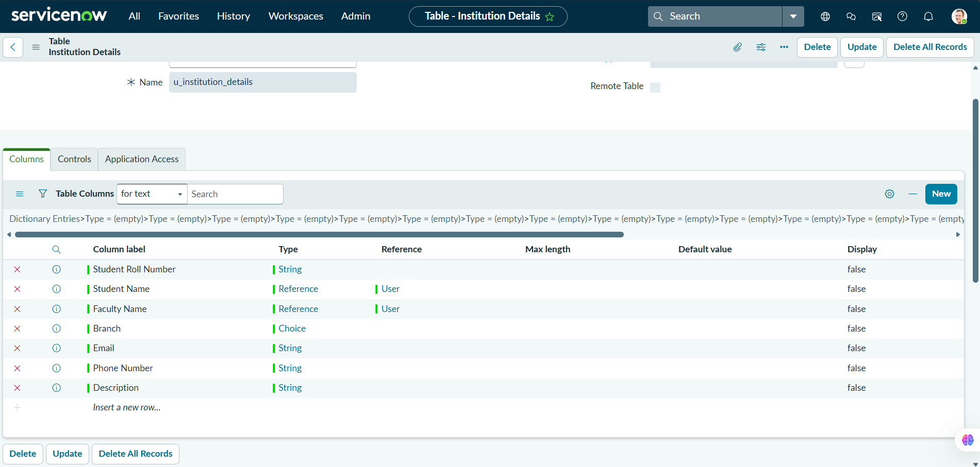

Institution Details table field configuration screenshot.
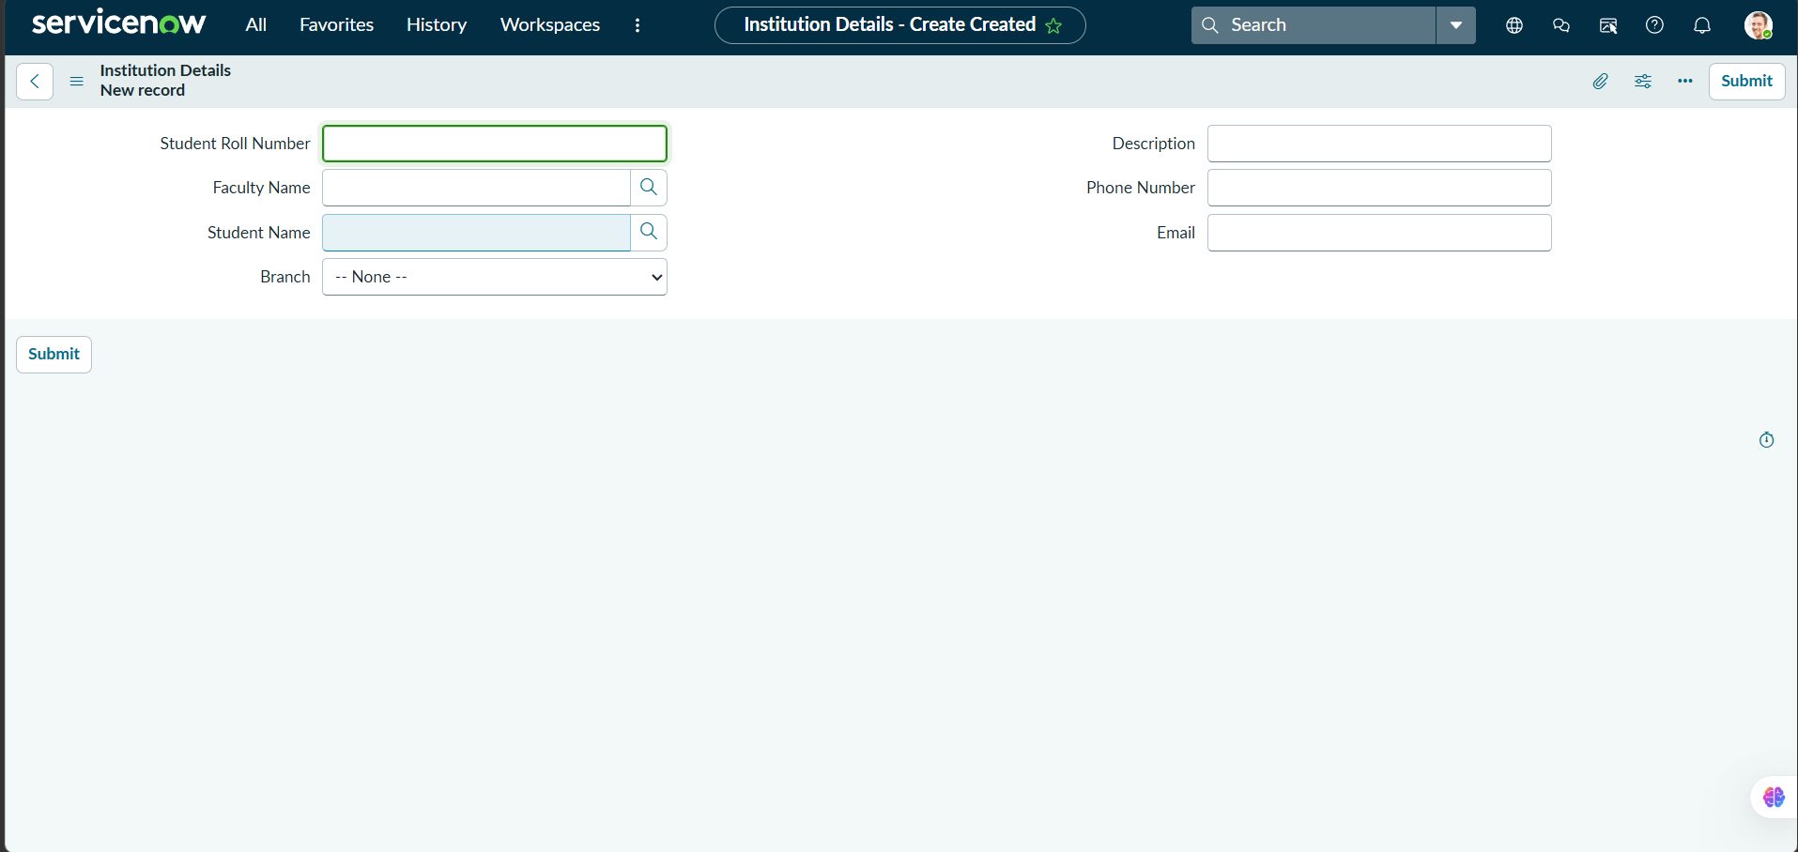

Branch choice field shows EEE, ECE, and CSE, plus a technical placeholder choice that should be removed before the final demonstration.
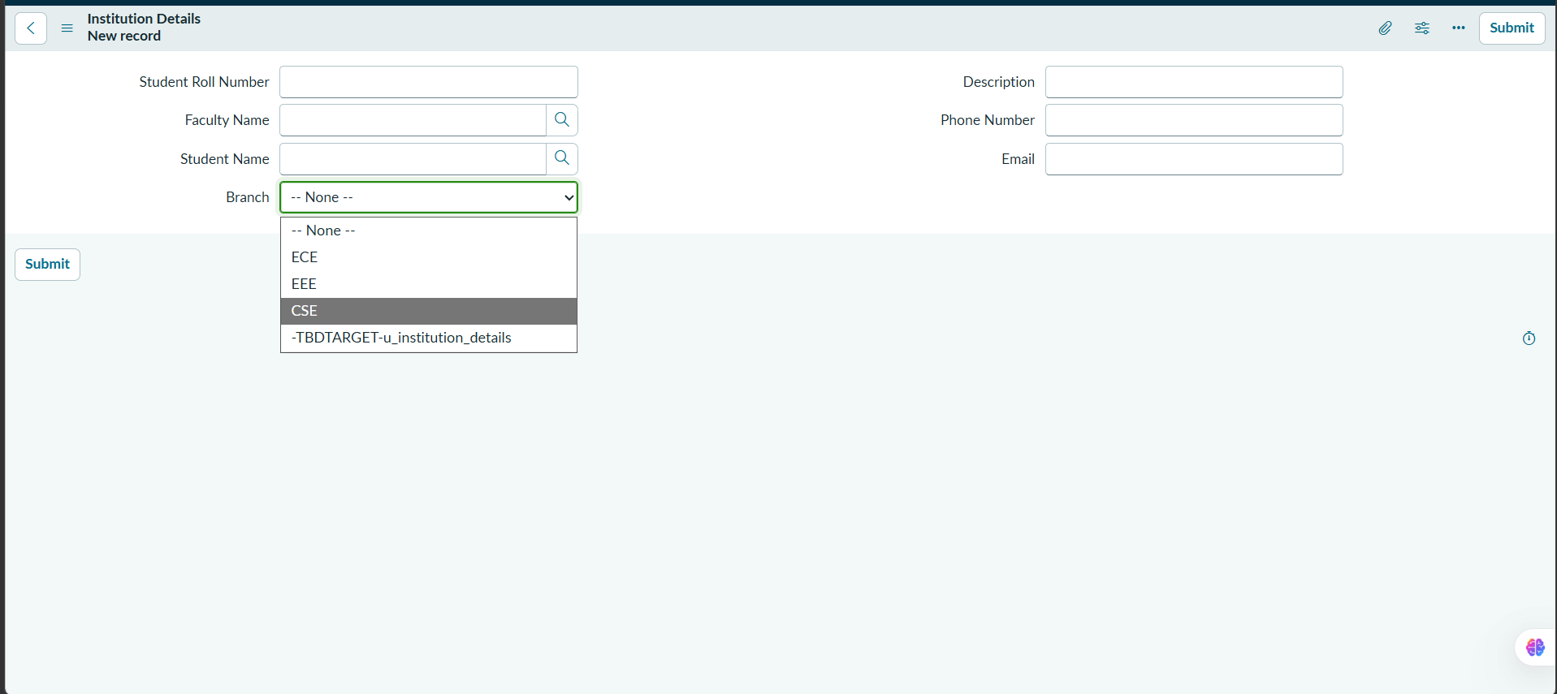

Sample record STU100: student Abel Tuter, faculty Abraham Lincoln, Branch ECE.
